Introduction: How to use the document

The Intake Definition Document is used by project submitters to select the appropriate project type when submitting new Ideas. New Intake ideas can either be categorized as Maintenance and Operations (M&O) or standard Projects. Before formally submitting a new Idea, it is important to know which to select in order for the submission to move through the appropriate process flow.

This document includes:
- Definitions of Project, M&O, Request, Program established and used by the Office of Information Technology (OIT) and the Project Management Office (PMO)
- Project Management checklists based on project priority: Critical, High, Medium, Low, and M&O

Table of Contents
Project Definition 1
Project characteristics 1
Examples of a formal Project 1
M&O (Maintenance & Operations) Project Definition 3
M&O project characteristics 3
Examples of M/O Projects 3
Program Definition 3
Program characteristics 3
Examples of a formal Program 3
Requests 4
Request characteristics 4
Examples of Requests 4
Portfolio Categories and Sub-Categories - Definitions1 5
OIT Ranking Definitions 6
Sub-Committee, OIT Ranking Exceptions 7

Project Definition
A project is a temporary endeavor undertaken to create a unique product, service, or outcome within a specific timeframe, scope, and budget. The project must have specific goals, source of funding, sponsorship, and defined business owner.

Project characteristics
- Accomplished by shared resources often only available during the project life cycle
- Usually involve cross-functional teamwork and significant coordination
- Uncertainty and risk are involved
- Outcome not fully known
- Changes the way the business operates
- Has specific deliverables, timelines, milestones, and constraints (schedule, budget, scope, resources)
- Significant communication efforts
- Formal training could be needed
- End users will undergo some form of change or disruption
- Outcome will require some kind of operational support upon completion

Examples of a formal Project
- New technology purchases and implementation
- Development and establishment of new IT service offering or new capabilities
- Procurement projects using the RFP/RFI/IFB/RFQ process
- Proof-of-concepts
- Business process re-engineering

M&O (Maintenance & Operations) Project Definition
M&O projects involve permanent ongoing or semi-permanent functional work to repetitively produce the same product or service to sustain the business. A rule of thumb to distinguish whether it is a project or just work is to ask, how often have we done this?

M&O project characteristics
- RTP will still need to be submitted for new funding requests
- Managed work is an effort that is large enough to warrant a team
- May be complicated enough to need a plan and someone to watch over it
- Low enough in both risk and complexity that a PMO PM is really not required
- It is a repeatable activity, meaning the effort has been done more than once
- With little uncertainty and lower overall risk

Examples of M/O Projects
- Hardware lifecycle refreshes to maintain support for existing services (Network)
- Application release updates
- Internal process improvement
- Operating system upgrades releases
- Database reorganizations
- Anything that needs to be onboarded (plug ins, FindTime)
- SharePoint workflows
- Server Migrations
- Decommissions (Databases, servers, services)
- Custom Reporting

Program Definition
A set of projects, programs and operations managed together to achieve an organization’s strategic objectives. A program helps to logically group related projects or demands under a single entity.

Program characteristics
- Coordination of related projects that are grouped together
- Bundling projects to manage the benefits as a collection, rather than individual units
- Portfolios can be analyzed for overall effectiveness and alignment with strategic objectives
- Involve more complex change management due to size or tied to organization’s strategy
- Involve senior level management and direction, in order to have more authority, influence, and power to resolve issues and make program wide decisions.

Examples of a formal Program
- Web Modernization (Governance, Infrastructure, Design)
- Telephone Upgrade/Implementation (Infrastructure, Design)
- CRM (Infrastructure, Design)

Requests Definition
Standard request for information, advice, service, hardware or software previously defined in the IT service catalogue. Generally low risk, relatively common/straightforward and follows a procedure for access to an IT service. If it requires Change Management (i.e. communication, training, process mapping etc.), then it is not a Request and is a type of project.

Request characteristics
- Impact touches a small group of users within the same unit ​
- Can be managed by one or two technical resources and significant co-ordination with other functional/technical areas is NOT required​.
- It does not have any dependencies to complete the request
- It does not have reputational impact/harm to the organization if the solution is implemented
- The resolution of the request does not involve contracts or other legal instruments​
- Does not require extensive testing​
- Relatively low risk ​
- Service offering already exist and no new functionality is needed. Note - if the request has a repeatable solution, but it will require planning, scheduled meetings/solutions, and a timeline is needed, then the request is no longer a request and it should be turned into a project.

Examples of Requests
- SSO setup
- Standard access request (i.e. software, system, etc.)​
- Access to a print share ​
- Laptop re-imaging ​
- Additional storage request

Portfolio Categories and Sub-Categories - Definitions1

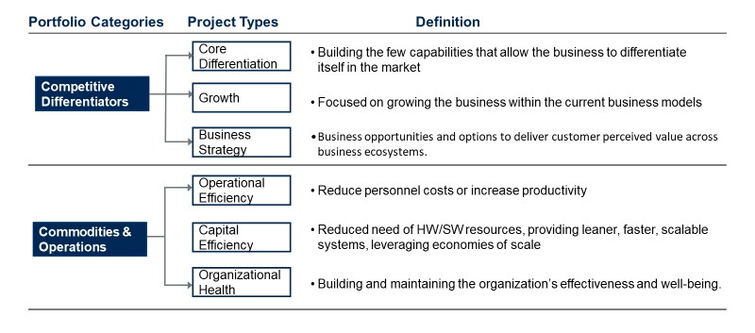
- Competitive differentiators: Increase or apply to business revenue to support the organization growth
- Commodities and operations: Support the organization’s functions to increase productivity and efficiency, and to reduce operational cost now & in the future

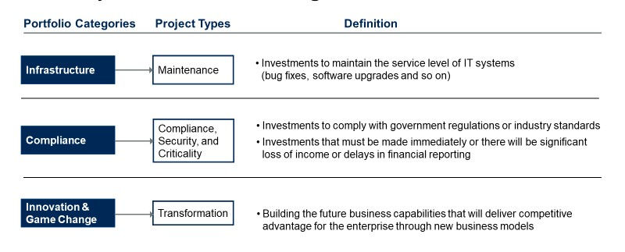
- Infrastructure: Physical structure for the organization to function, operational risks, reputational risks
- Compliance: Regulatory data, processes, and structure for the organization to be allowed to function, legal risks
- Innovation: Higher risk investments for the organization to stay ahead of the competitions

1 Source: Gartner

OIT Ranking Definitions

OIT Ranking | Business Impact | Characteristics | Examples
A = Critical | Requested by the President, Poses a security Threat/risk, Regulatory or Compliance, Physical impact to the campus or infrastructure compromised, Reputation Impact | - Significant collaboration between multiple IT teams and business units.  - Campus wide impact  -Postponement will result in irrevocable damage.  - Explicitly aligned to the University and OIT vision. | -CRM  -Telephone  -Web Modernization  -eLearning TM  -NAC Deployment
B = High | High Political Sensitivity; Some Impact to Critical Service; Above Average Impact to Critical Service; Above Average Financial Impact (+ or -) | - High collaboration between few OIT teams and business units.  - Impact to multiple business units  -High risk to organization services if project is not implemented, but mitigation plans are available in the meantime.  - Primarily aligned to the University and OIT vision. | -System upgrades  -Teams Calling
C = Moderate | Moderate Political Sensitivity; Off-Hours Impact to Critical Service; Average Financial Impact (+ or -) | - Some collaboration needed between few OIT teams and a business unit.  - Moderate impact to a single or few business unit.  -Project could be delayed for up to 12 months+ without significant risk/impact.  - Partially aligned to the University and OIT vision. | -Move to Trinity Hall  -Operationalize the Onboarding toolkit  -MARS Reporting
D = Low | Low Political Sensitivity; Impact to Enabling System; Minimal Financial Impact (+ or -) | - Minimal collaboration needed.  - Minimal impact to business units.  -Project could be postponed indefinitely without significant risk/impact.  - Peripherally addresses the University or OIT vision. | -Android devices via Intune  -Jamf MDM migration
N/A | Not reviewed by the sub-committee. | Project does not meet the sub-committee guidelines of a Critical or High priority project. | - M&O  - Project that are more than 80% complete

Sub-Committee, OIT Ranking Exceptions
The following projects are exempt from the sub-committee prioritization review and by default will be assigned the highest OIT Ranking.

- Requested by the President
- Poses a security Threat/risk
- Regulatory or Compliance
- Physical impact to the campus or infrastructure compromised
- Reputation Impact

